Download and install nodejs by visiting <https://nodejs.org/en>

Type these commands in terminal.

>node –v

>npm –v

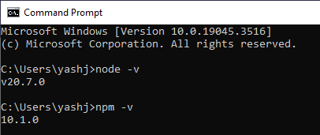

>npm install expo-cli-global or install –global expo-cli

>npx create-expo-app Incredible_Todo_list_App

>cd Incredible_Todo_list_App

>Code .

>npm start

